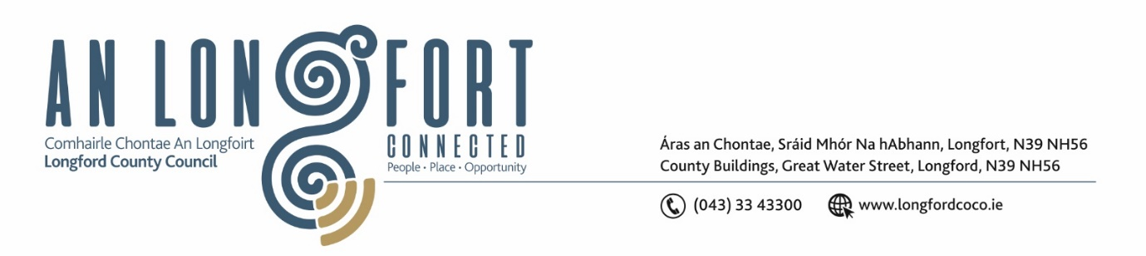

Please note meeting will be held in the Council Chamber and via Microsoft Teams.

5 May 2022.

Chuig: Gach Ball don Chomhairle.

A Chomhairleoir,

Iarrtar ort bheith i láthair ag Cruinniú Míosuil Chomhairle Chontae Longfoirt a tionólfar i Seomra na Comhairle, Aras an Chontae, Longford agus via MS Teams are an Chéadaoin 11ú Bealtaine 2022 ag 3pm chun gnó a dhéanamh d’réir an Chláir thíos.

You are requested to attend the Monthly Meeting of Longford County Council to be held in the Council Chamber and via Microsoft Teams on Wednesday 11 May 2022 at 3pm to transact business, as set out on the Agenda hereunder.

Mise le meas,

Ann Marie Mc Keon
__________________
Ann Marie Mc Keon
Meetings Administrator.

C L Á R

Prayer before meeting.

Presentation by Skater’s Committee

1. Confirmation of Minutes of Monthly Meeting of Longford County Council held on 13 April 2022– copy enclosed.

2. Matters Arising.

3. Declaration of Interest by Members.

4. To note Management Report – enclosed.

5. To note adopted Minutes of Corporate Policy Group Meeting held on the
8 March 2022 – enclosed.

6. Planning and Project Delivery

(a) To note Planning Applications received since last meeting of the Council.

(b) To note adopted Minutes of meeting of Climate Action and Planning Strategic Policy
Committee held on the 21 January - enclosed.

7. Community, Corporate and Enterprise

(a) To note adopted Minutes of meeting of Placemaking Strategic Policy
Committee held on the 31 January 2022 - enclosed.

(b) Confirmation of dates for Annual General Meeting:

Longford County Council 29 June 2022
Granard Municipal District 28 June 2022
Longford Municipal District 22 June 2022
Ballymahon Municipal District 23 June 2022

(c) Corporate Plan Update - NOAC Report.

(d) Polling Scheme Review – to follow.

(e) To approve grants under the 2022 Intercultural Grants Scheme – enclosed.

(f) Notice of Motions, submitted by Councillors, as listed hereunder –

Councillor Garry Murtagh

I welcome the online application for the Community Grant Support Scheme 2022 for community groups, however I am proposing that a hard copy option be made available to Community Groups whose members may not be computer literate, have access to the internet or a computer.

Councillor Martin Monaghan

“I call on Longford County Council to provide and install playground inclusion boards in all playgrounds around the county. They are wonderful tools for children with autism, Down Syndrome etc. These boards and communication portals are in common use in schools and this measure would be the next step in making our playgrounds more inclusive for all children.”

8. Infrastructure, Housing and Innovation

(a) To note adopted Minutes of meeting of Strategic Infrastructure Strategic Policy
Committee held on the 3 February 2022 - enclosed.

(b) Item referred from Strategic Infrastructure Strategic Policy Committee Meeting held
on the 21 April 2022:

- To approve Longford County Council’s updated General Information
Handbook and Home Maintenance Handbook for Tenants - enclosed.

- To approve Longford County Council’s Strategic Plan for Disabled People 2022-2027 and to report on progress in Q1 2022 – enclosed.

(c) Notice of Motions, submitted by Councillors, as listed hereunder –

Councillor Garry Murtagh

I welcome the recent increase to the budget for Housing Adaptation Grants for Older People and People with a Disability however, these increases do not go far enough. I am calling on the support of the elected members in writing to Darragh O'Brien Minister for Housing, Local Government and Heritage, Peter Burke Minister of State for the serious consideration and the increase to the amount allocated to each available Grant. Due to the spiralling costs and inflation of materials and labour, these Grants are no longer adequate in supporting the completion of works. In the majority of cases the applicant simply, cannot afford to carry out the necessary adaptions and repairs to their homes, these grants were understandable reduced by approximately 25 % in 2008 due to the downturn in the economy and have not been increased, leaving the most vulnerable in our society even further behind.

9. Finance

(a) To note adopted Minutes of meeting of Governance Strategic Policy
Committee held on the 2 February 2022 - enclosed.

(b) Item referred from Governance Strategic Policy Committee Meeting held
on the 26 April 2022 – Anti Fraud and Corruption Policy – enclosed.

(c) Consideration of Annual Financial Statement for Year ended 31 December 2021 –
- hard copy by post.

(d) Consideration of Approval of Additional Expenditure under S104(7) of the Local
Government Act 2001.

(e) To note 2021 Audit Committee Annual Report - to follow.

(f) To note Circular LG 03/2022 Re: Attendance requirements for Elected Members –
enclosed.

10. General

(a) Notice of Motions, submitted by Councillors, as listed hereunder –

Councillor Paul Ross

That Longford County Council call on the Minister for Finance Paschal Donohoe to remove VAT on AED Defibrillator Devices.

Councillor Paraic Brady

“I call on Longford County Council to write to minister for Agriculture to look at
exporting our pigs live to China as there is a huge shortage of pigs due to swine flu”.

Councillor Garry Murtagh

I am calling on Longford County Council. to write to the Minister of Business, Employment & Retail, Damien English for the consideration of a 3 tier Vat rate. The propose of this is to save small and rural business that have been family run institutions for generations, that are no longer financially viable to operate let alone for anyone to invest in or take over the running off. There needs to be serious investment/ incentives for these businesses such as pubs, shops etc. in small villages and rural areas in order to save these invaluable services that are the very fabric of rural Ireland.

11. Correspondence

- Guidance regarding media interaction with state provided services for people
arriving from Ukraine – enclosed.

12. Training – enclosed.

13. Votes of Sympathy

